Appositive Attribute

✅ What is Appositive Attribute
# Source: AI Source: Provided by: [Data Path: Persons Table -> ID Column: 1, Name_En Column: Motasem Essam] -> From: [Chatgpt (GPT‑5 Mini)] on [8/7/2025]
An Appositive Attribute is a noun, noun phrase, or noun clause that renames or further identifies a noun it follows (or occasionally precedes).
It functions like an adjective by giving additional, defining, or explanatory information about a noun — thus serving as an attribute.

🔹 Structure:
# Source: AI Source: Provided by: [Data Path: Persons Table -> ID Column: 1, Name_En Column: Motasem Essam] -> From: [Chatgpt (GPT‑5 Mini)] on [8/7/2025]
Appositive = Noun/Noun Phrase/Clause placed next to another noun
It does not act independently but explains or defines the noun beside it.

🔹 Types of Appositive Attributes:
# Source: AI Source: Provided by: [Data Path: Persons Table -> ID Column: 1, Name_En Column: Motasem Essam] -> From: [Chatgpt (GPT‑5 Mini)] on [8/7/2025]
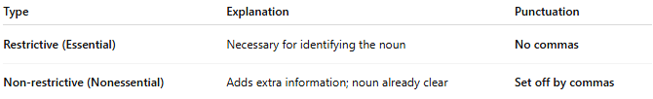
Type | Explanation | Punctuation
Restrictive (Essential) | Necessary for identifying the noun | No commas
Non-restrictive (Nonessential) | Adds extra information; noun already clear | Set off by commas

🔹 Examples in Sentences:
# Source: AI Source: Provided by: [Data Path: Persons Table -> ID Column: 1, Name_En Column: Motasem Essam] -> From: [Chatgpt (GPT‑5 Mini)] on [8/7/2025]
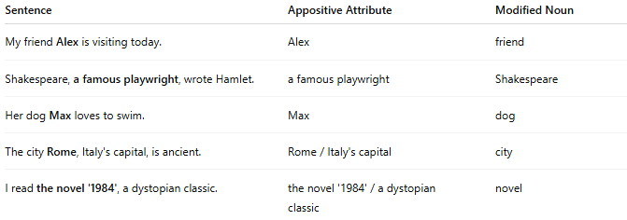
Sentence | Appositive Attribute | Modified Noun
My friend Alex is visiting today. | Alex | friend
Shakespeare, a famous playwright, wrote Hamlet. | a famous playwright | Shakespeare
Her dog Max loves to swim. | Max | dog
The city Rome, Italy's capital, is ancient. | Rome / Italy's capital | city
I read the novel '1984', a dystopian classic. | the novel '1984' / a dystopian classic | novel

🔹 Quick Summary Table:
# Source: AI Source: Provided by: [Data Path: Persons Table -> ID Column: 1, Name_En Column: Motasem Essam] -> From: [Chatgpt (GPT‑5 Mini)] on [8/7/2025]
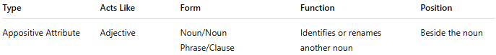
Type | Acts Like | Form | Function | Position
Appositive Attribute | Adjective | Noun/Noun Phrase/Clause | Identifies or renames another noun | Beside the noun

🔸 Note:
# Source: AI Source: Provided by: [Data Path: Persons Table -> ID Column: 1, Name_En Column: Motasem Essam] -> From: [Chatgpt (GPT‑5 Mini)] on [8/7/2025]
- Appositive attributes are common in descriptive writing, definitions, and expository texts.
- They often clarify who or what a noun refers to.

